Social Networking
A Treatise on Social Ecology and Milieu
by Thee Social Media Hegemon

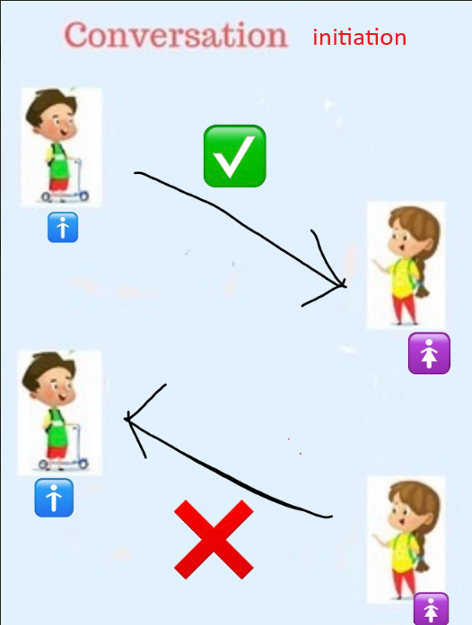
(fig: how conversation is traditionally supposed to start between genders)
(this treatise is not about gender though)

Different hormones come into play when networking. We can split them up into the Raven hormones (primarily oxytocin), the Acronyte hormones (testosterone and oestrogen), and the Infernal hormones (dopamine and adrenaline).
They are all separate, even each individual hormone, but we can separate the raven hormones from the infernal and acronyte hormones because the infernal and acronyte hormones are the ones actually responsible for inciting networking, and the raven hormones come into play during networking.

You either gone incite networking through the infernal hormones or acronyte hormones.
The infernal hormones are boomlike. When it comes to the infernal hormones and their interplay with social networking, they are basically the “fight or flight” hormones. We describe them as boomlike.
We can separate the function of adrenaline and dopamine since truthfully its adrenaline that is responsible for the fight or flight response and dopamine is more of a support hormone to aid the muscles during the burst of energy.
The acronyte hormones are oestrogen and testosterone which both play a different role in networking. We can say that oestrogen is “the paternality hormone” and testosterone is “the assasinative hormone”. But what those terms mean in terms of networking, it’s that oestrogen is responsible for building; be it building relationships between a person and another person or building a relationship between a person and a thing.
On the other hand, testosterone is responsible for what can be described as social focus. So locking on to a person or a thing.
You can see that both oestrogen and testosterone are required for inciting networking, but so are the infernal hormones. A better thing to say is that testosterone has a specific interaction with the acronyte hormones in that once locked onto another person or a thing, the “fight or flight” mechanism can be then triggered within a person after the onset.
Whatever the case though, the acronyte hormones grouped together are generally more responsible for building relationships and the infernal hormones are generally more responsible for destroying relationships.

The raven hormones such as oxytocin come into play during networking since they are more about creating that “good feeling” and warmth associated with social bonding. This is separate from the oestrogenic aspects of the acronyte hormones. At this point it is good to mention that none of these hormones exist in a vacuum without the others, and so naturally there will always be interplay between them during social networking. But we must separate them in order to reason about the part each separate component plays.

Cortisol is the hormone that reduces stress. Without getting into the weeds of what stress actually is, we know for sure that stress is purely negative toward social interaction. It is a simple affair to where, in terms of stress, you just want it to be as low as possible.
You can think of it as like pain and the responsibility of the response of pain in the body. It has its use since it allows you to account for different areas and systems in the body, but overall you just want the experience of the response to be as low as possible for its central point of homeostasis. It exactly the same for stress; again, without getting into the specifics of what is actually is.
As a result we want the body to basically make as much use of the peaks and crests of cortisol as possible so that the experience of stress is as low as possible.
A side effect of this, is that the body will produce a lot of apocrine sweat (which is the secondary type of sweat, the other one being eccrine sweat which is just for cooling).

Sometimes, you come into conversation or meeting with yourself while in the social milieu. Necessarily what I’m saying is that within the social milieu, the self also appears — and appears as a detachment from self as an experience. We can call this ‘self consciousness’. It can potentially be a distraction to participation on the social setting.

Fear, fear of the unfamiliar, fear of the emotionally overwhelming etc are all distinct and different.

